**COMP 203 Data Structures and Algorithms, Fall 2024**

**Lab Assignment 4**

**Deadline: 28.10.2024 11:00 am**

**Read the questions and rules carefully. They are clear and well defined.**

**Rules:**

1. **No Cheating:** You are not allowed to collaborate with your friends and use any kind of websites or AI. If your homework gives a sign of any of them, **directly it will be graded as zero**.
2. **Goal:** Please do your homework alone. Our main aim is to **learn**.
3. **Submission:** Submit your work in **a single java file.** **DON’T USE ZIP/RAR etc. In these cases, your points will be deducted by 30%.**
4. **Coding policy:** Explain your code in comments. **This is a must!**
5. **Latency policy:** A 30% deduction will be applied for each day of late submission.
6. Do not use built-in functions of java.

**Files to submit:** CDoublyLinkedList.java

We have circular doubly linked list as follows:

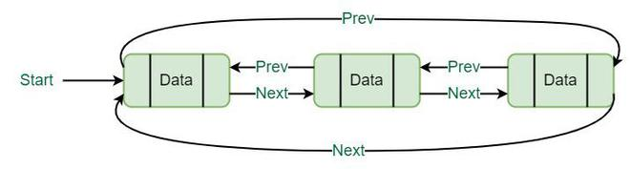

**1. Circular Doubly linked List**

a. Create a generic Node<T> Class that has a constructor with parameter T data for circular doubly linked list. (10pt)

b. Create a generic CDoublyLinkedList <T> Class that has an empty constructor. In this CDLL, you have access to header node. (10pt)

c. Write a function with the name “public void append(T data)” to insert a node having value *data* at the end of the CDLL. (15pt)

d. Write a function with the name “public void delete(T data)” to delete the node that has the value *data*. (15pt)

e. Write a function with the name “public void display()” to print the node values in the CDLL. (15pt) It should print in the following format:

header <->X <-> Y <->Z <-> header

f. Write a main function that has an String type DLL from CDoublyLinkedList class (with name StrCDLL) and do the following operations on it in the order of: (10pt)

StrCDLL.append(“hello”);

StrCDLL.append(“from”);

StrCDLL.append(“the earth”);

StrCDLL.display();

StrCDLL.delete(“from”);

StrCDLL.display();

Output should be in the following form:

header <->”hello” <-> “from” <->”the earth” <-> header

header <->”hello” <-> “the earth” <-> header

g. In the same main function, create an Integer type CDLL from CDoublyLinkedList class (with name IntCDLL) and do the following operations on it in the order of: (10pt)

IntCDLL.append(4);

IntCDLL.append(8);

IntCDLL.append(15);

IntCDLL.append(16);

IntCDLL.display();

IntCDLL.delete(8);

IntCDLL.display();

Output should be in the following form:

header <-> 4 <-> 8 <-> 15 <-> 16 <-> header

header <-> 4 <-> 15 <-> 16 <-> header

h. What is the Big-O worst case time complexity of append function where the size of CDLL is n? Explain why. (5pt)

What is the Big-O worst case time complexity of delete function where the size of CDLL is n? Explain why. (5pt)

What is the Big-O worst case time complexity of display function where the size of CDLL is n? Explain why. (5pt)

Write the answers to these questions as comment lines in your code at the end of your code.